Substantial performance upgrade in high capacity

[Watch Video](https://www.kingston.com/en/video/play?videoId=hyIU3ElX_BQV8le5SF-IuNO3oLjvmd5stI7LLgT9p-RZxBBMEjAyKRW5QYZDVnG1sXkUQQSvpJ0qveVWMfK05Q2&start=0&autoPlay=False&chromeless=False&captionOption=No)

SNV2S

* [Intro](https://www.kingston.com/en/ssd/nv2-nvme-pcie-ssd#product-features)
* [Key Features](https://www.kingston.com/en/ssd/nv2-nvme-pcie-ssd#key-feature)
* [Specifications](https://www.kingston.com/en/ssd/nv2-nvme-pcie-ssd#specifications)
* [Resources](https://www.kingston.com/en/ssd/nv2-nvme-pcie-ssd#links)
* [Datasheet](https://www.kingston.com/datasheets/snv2s_us.pdf)

[**Buy**](https://www.kingston.com/en/ssd/nv2-nvme-pcie-ssd#atc)

NV2 PCIe 4.0 NVMe SSDUpgraded performance for thinner notebooks and systems

Kingston’s NV2 PCIe 4.0 NVMe SSD is a substantial next-gen storage solution powered by a Gen 4x4 NVMe controller. NV2 delivers read/write speeds up to 3,500/2,800MB/s1 with lower power requirements and lower heat to help optimize your system’s performance and deliver value without sacrifice. The compact single-sided M.2 2280 (22x80mm) design expands storage up to 4TB2 while saving space for other components, making NV2 ideal for thinner notebooks, small form factor (SFF) systems, and DIY motherboards.

Available in capacities from 250GB – 4TB2 to give you all the space you need for applications, documents, photos, videos, and more.

* Gen 4x4 NVMe PCIe Performance
* Ideal for Laptops & Small Form Factor PCs
* Capacities up to 4TB2

Key Features



Gen 4x4 NVMe PCIe Performance

Delivers read/write speeds up to 3,500/2,800MB/s1 for an overall faster system.



Ideal for Systems with Limited Space

Easily integrate into designs with M.2 connectors. Perfect for thin laptops and small form factor PCs.



Extended Capacities

Available in a range of high capacities up to 4TB2 to meet your data storage requirements.

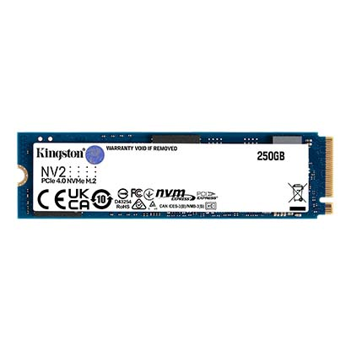

* [SSD | NV2 | SNV2S/250G](javascript:void(0))
* [SSD | NV2 | SNV2S/250G](javascript:void(0))
* [SSD | NV2 | SNV2S/250G](javascript:void(0))

Capacity

 250GB

 500GB

 1TB

 2TB

 4TB

* Part Number: SNV2S/250G

[**Where to Buy**](https://www.kingston.com/en/wheretobuy)

Specifications

|  |  |
| --- | --- |
| Form Factor | M.2 2280 |
| Interface | PCIe 4.0 x4 NVMe |
| Capacities2 | 250GB, 500GB, 1TB, 2TB, 4TB |
| Sequential Read/Write1 | 250GB – 3,000/1,300MB/s 500GB – 3,500/2,100MB/s 1TB – 3,500/2,100MB/s 2TB - 4TB – 3,500/2,800MB/s |
| NAND | 3D |
| Endurance (Total Bytes Written)3 | 250GB – 80TB 500GB – 160TB 1TB – 320TB 2TB – 640TB 4TB – 1280TB |
| Storage Temperature | -40°C~85°C |
| Operating Temperature | 0°C~70°C |
| Dimensions | 22mm x 80mm x 2.2mm |
| Weight | 7g (All capacities) |
| Vibration Operating | 2.17G (7-800 Hz) |
| Vibration Non-operating | 20G (20-1000Hz) |
| MTBF | 2,000,000 hours |
| Warranty/Support4 | Limited 3-year warranty with free technical support |